FALL 2024  
MEC325: INTRODUCTION TO ENGINEERING DESIGN  
DESIGN PROJECT  
**FINAL REPORT**

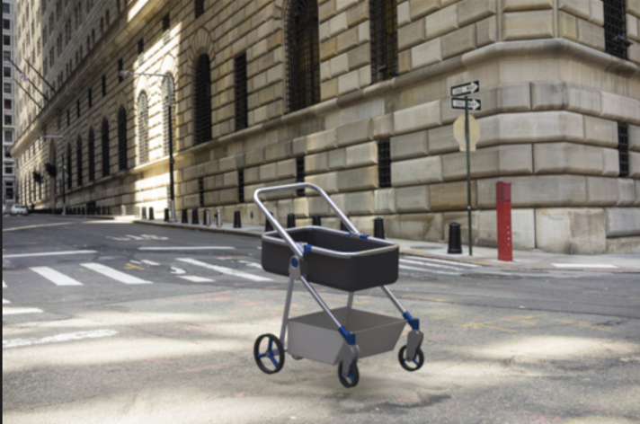

Assistive Transport of Children

when Walking

TEAM 1305

# table of contents

**table of contents** **1**

**team declaration** **2**

**executive summary** **1**

**design brief summary** **2**

**background** **4**

**personas & SUCs** **7**

Persona: John 7

Persona: Margaret 7

Persona: Rachel 8

Persona: Jameson 8

Persona: Thanh 8

Persona: Caitlynn 9

**requirements** **10**

**integrated design concept** **18**

**systems analysis** **19**

**detailed design** **20**

**design issues** **21**

**CAD drawings** **22**

**references** **23**

# team declaration

We, the undersigned members of Team SSNN in MEC325, agree that all team members have abided by all Ryerson Policies and course rules.

We furthermore accept that any violation of Ryerson Policy or course rules will lead to a grade penalty or charges of academic misconduct.

| STUDENT NAME | STUDENT NUMBER[1] |
| --- | --- |
| Osman Asif | 35477 |
| Codin Nguyen | 37911 |
| Osama Noureddin | 46598 |
| Khiem Nguyen | 13735 |
| Andrej Draskovic | 32844 |
| Yee Yin Kwok | 51256 |

# 

# 

# executive summary

As previously stated in the [Design Brief](https://docs.google.com/document/d/1m8Y97Fyu418LrBMM7_kaH58dcY6xXEpoC8NbKqFQzBs/edit?tab=t.0#heading=h.plg5fdf1bsja), the main goal of this project is to design a Assistive Transport for Children when Walking. As outlined in the Design Brief Summary are all the specific factors and goals that needed to be met.

After several Situation Scans as seen in the Background, the final intervention must match several use cases. It must be usable in a variety of climates and environments such as urban streets and public transportation to off road environments[1]. The primary user would include caregivers ranging from 20-80 years old and co-users would be infants to children up to 5 years old [1].

After considering the user base, several Requirements were made in order to provide a product that fits. The Requirements were separated into 5 categories: Functionality, Usability, Productibility, Maintainability, and Sustainability. Some examples of these include automatic safety locks, easy disassembly, easily replaceable parts, a seat that can recline to 180 degrees, and be made of at least 50% recycled materials [1], in respective order.

Using these requirements and the design concepts from milestone 1 and 2, an integrated design concept was made. This final design has many features taken from previous design concepts that would improve the user experience. These features include a fifth wheel, a foldable design, spring suspension , and a braking system.

Despite redesigning the intervention for the third time, design issues will still be present. By documenting these issues, it allows for further improvement and growth as the product continues to be developed.

Detailed designs and CAD drawings were made to display the final design concept integrated together. Each individual part that was designed in CAD gives a detailed visual on how each part interacts with each other as well as a brief description of what custom designed parts do.

# design brief summary

The design brief concerns the creation of Assistive Transport for Children when Walking ([Design Brief](https://docs.google.com/document/u/0/d/1m8Y97Fyu418LrBMM7_kaH58dcY6xXEpoC8NbKqFQzBs/edit)). The objective is to design a human-powered vehicle for newborn to toddler-aged children. This includes strollers, baby carriages and other potential interventions [5].

Strollers provide a safe way for caregivers to transport their children and be with them while allowing mobility. While they differ in cost and quality, the same basic needs all need to be met. These include the comfort of caregiver and child, storage solutions, ease of use, and affordability, to name a few. The inclusion of many different users is also a necessity, as is storage.

A NGO came forward with a request for a design proposal for a stroller. They had many concerns about accessibility, sustainability, and comfort. Ultimately, our team these aspects most important [5]:

* Include more people as users
* Ensure ethical and sustainable practices throughout lifecycle
* Usable by a single untrained person
* Remain safe in all real world use scenarios
* Account for Human Factors in all stages of use and lifecycle

The goal is to design a human-powered vehicle for newborn to toddler-aged children that enhances the usability, safety, and comfort of traditional strollers while accommodating a broad range of caregivers. This vehicle must be easy to operate by a single untrained user, addressing real-world challenges like public transit, hikes, and public spaces. It should be durable, affordable, and adaptable to the diverse needs of families, including multiple users such as siblings or grandparents. Prioritizing low environmental impact, safety, and ethical considerations throughout its life cycle, the design must also improve the comfort and dignity of both users and co-users [5] ([SKB: goals](https://docs.google.com/document/d/1rz1rAIiTk1ZrDwnuDpjA3R7Bg03I_6vg5hg59ztqgEg/edit?tab=t.0#bookmark=id.2fbkymz6klj8)).

# 

# background

**Design Objective:** Create a versatile, human-powered vehicle for newborns to toddlers, prioritizing safety, comfort, and usability for diverse caregivers. Key design elements include ease of operation, durability, adaptability, affordability, and environmental sustainability, with a focus on safety and ethical standards.

**Environment**

**Urban and Suburban Settings:**

* **Temperature:** Operates effectively from -10°C to 40°C, accommodating urban heat islands and extreme weather conditions.
* **Precipitation:** Resilient to light rain (2.5–10 mm/hr), heavy rain (>50 mm/hr), and snow accumulation (up to 5 cm/hr).
* **Lighting:** Suitable for low-light use (5–50 lux).

**Public Transport and Travel:**

* **Storage:** Compact design fits 25 × 40 × 50 cm compartments.
* **Maneuverability:** Navigates spaces as narrow as 60–80 cm.

**Rural, Off-Road, and Beach Settings:**

* **Terrain Adaptability:** Handles uneven surfaces like dirt, gravel, and sand, with slopes up to 15°.
* **Weather Exposure:** UV-resistant (levels 6–11) and stable in winds up to 30 km/h, withstanding wear from mud, dust, and saltwater.

**Competition**

**Common Features:**

* Waterproof materials, adjustable harnesses, and durable frames with versatile wheels.

**Notable Examples:**

* **GB Pockit+ All-City:** Ultra-compact, urban-friendly.
* **BOB Gear Revolution Flex 3.0:** Rugged, high-performance.

**Users**

**Primary Users (Caregivers):**

* **Strength:** Supports users handling up to 10–15 kg.
* **Height Range:** Comfortable ergonomics for heights from 150–190 cm.
* **Mobility:** Accessible to those with limited grip strength (20–30 N).
* **Cognition:** Simple mechanisms enable quick adjustments within 5–10 seconds.

**Secondary Users (Children):**

* **Weight and Size:** Suitable for newborns (3 kg) to toddlers (20–25 kg, 50–100 cm tall).
* **Safety:** Provides stability for children still developing balance and motor skills.
* **Temperature Sensitivity:** Protects against rapid temperature changes exceeding ±5°C.

**Co-Users (Extended Caregivers):**

* **Physical Limitations:** Designed for older caregivers with reduced strength (10–15 N grip force).
* **Adjustability:** Accommodates different caregivers within 10–15 seconds.

**Strategy**

**Market Segment:**

* Targets caregivers aged 20–45 in urban, suburban, and rural areas, offering ergonomic, versatile solutions.

**Degree of Innovation:**

* Combines existing stroller features into a modular, eco-friendly design.
* Key elements include adjustable seating, compact folding, and suspension for diverse terrains.

**Time to Market:** 3–4 years:

* Research and development (Years 1–2).
* Testing and refinement (Years 3–4).

**Production:**

* Annual output of 700,000 units, aligned with competitor benchmarks.

**Customization:**

* Offers modular components for seating and maneuverability, catering to diverse user needs and environments.

# personas & SUCs

## Persona: John

John is a 42-year-old male living with his 2-year-old toddler in a compact apartment complex with minimal storage. John is a single father who works from home and manages both his graphic designing job and the caretaking of his toddler. John is quite busy with his job, he works extra hours in order to provide for his toddler, and his financial situation forces John to budget appropriately and spend responsibly. Despite that John makes as much time as he can to take his toddler for walks. John has a significant and frequent need for long walking commutes in order to reach places such as grocery stores, John also takes his toddler with him on these commutes. Due to John's recent back surgery, it prohibits him from lifting heavy objects and limits movement to prevent any pain from occurring. Furthermore, John is a tall individual, at 188 cm needing a design that accommodates above average heights in order to comfortably maneuver with the stroller. John faces the challenge of maneuvering through the busy and uneven terrain of the city and due to his lack of strength, John stresses the need for high-stability in order to prevent tipping or uncomfort for his toddler. Moreover, Johns stresses the need for his toddler to develop good posture habits from a young age to not end up with any future back issues like himself.

| **SUC 4** | **John takes his toddler with him to the grocery store** |
| --- | --- |
| **Owner** | Osman |
|  | On a typical afternoon John needs to go grocery shopping, taking his toddler along with him. Traversing the busy streets of the city he walks through the rough and uneven terrain. John walks through several blocks, ensuring his toddler is comfortable and shaded well from the blazing sun using an umbrella. Due to his back injury, John struggles with pushing the stroller with the necessary force consistently, which creates a more difficult ride for him and his toddler. Furthermore, due to his staggering height, the handlebars are positioned quite low for him, creating an unnatural wrist position and putting extra strain on his back and shoulders. After arriving at the grocery store, John carries his groceries in the bags given which add onto the weight and strain on John. After arriving home, John struggles in accommodating a compact area for the design, resulting in a larger space being occupied then intended.  **Relevance:** This Scenario highlights the importance of an intervention that incorporates many aspects that allow for an easy, safe and comfortable experience for John and his toddler. As John goes on his grocery trip, an intervention that is capable of long rides without fail, for long-term use without major wear and tear is necessary for John. Furthermore, an intervention that has high stability through a variety of terrains allows for easy maneuverability through the busy and unpredictable city streets. Additionally, a means to add in creating less force required to push the assistive transport aids John to not be prone to injury and allow for a more safe ride. Adjustable handlebars are also essential for John’s height allowing for neutral wrist position and less strain on his back. Lastly, a means of storage is essential for the intervention, allowing for means to store the grocery without having to carry it while maneuvering the design. |

## Persona: Margaret

Margaret is a 68-year-old woman who lives alone but often cares for her 2-year-old granddaughter, Emily, while her daughter is at work. Margaret was diagnosed with early-stage dementia two years ago, which occasionally affects her short-term memory and makes complex tasks a little confusing. Despite this, she is strong and active, walking daily and enjoying gardening to stay physically fit and mentally engaged. She values her independence and is determined to keep doing things on her own as much as possible. Margaret prefers walking to driving, finding it simpler and safer. She often takes Emily to the park. Margaret is deeply caring and patient, and time spent with Emily is something she treasures. It’s a reminder of all the meaningful connections in her life, and she feels grounded and purposeful caring for her granddaughter. As her condition progresses, Margaret looks for tools and products that allow her to remain involved with her family safely and independently, finding joy in the little moments with Emily.

| **SUC 3** | Margaret takes Emily to the park in the afternoon |
| --- | --- |
| **Owner:** | Codin |
|  | On a sunny afternoon at 3:00 p.m., Margaret, a 68-year-old with early-stage dementia, sets out with her 2-year-old granddaughter, Emily, for a walk to the park. She values her independence, and walking feels safer and simpler than driving, especially with Emily in tow. Margaret brings along a lightweight device and a small backpack packed with essentials for their outing.  As they make their way down the sidewalk, Margaret starts to feel a bit tired and thirsty. She spots a bench up ahead and decides to take a quick break. Carefully positioning the device beside her, she sets the brakes to keep Emily secure before digging through her backpack for her water bottle. After a few moments of searching, she finally finds it, taking a sip and feeling a bit refreshed. Rested, Margaret continues on to the park, where she and Emily spend a joyful afternoon together.  **Relevance**: This scenario highlights the importance of an intervention that supports Margaret’s physical and cognitive needs, ensuring both safety and ease of use. As Margaret becomes tired during the walk, she benefits from an intervention that’s lightweight and easy to control, minimizing physical strain. The device’s secure brakes provide peace of mind when she needs a rest, while an accessible and organized storage compartment would help her locate essentials quickly, reducing frustration and distraction. Additionally, simple visual cues or labels could aid Margaret in using the device confidently, even with memory challenges. These features would allow Margaret to enjoy outings with Emily independently and safely. |

## Persona: Rachel

Rachel is a 35 year old female who regularly takes care of her 3-year old niece. She recently quit her full time job at Tim Horton’s due to worsening multiple sclerosis which causes her to lose balance after standing on her feet for an extended period of time. She hopes to find a new job, but in the meantime she spends her time playing dungeons and dragons in her best friend's basement. After the birth of her sister’s son, going on walks in the park with her niece has been almost the only time that she spends time outdoors. She especially struggles to leave the house during the rain, as her thick prescription glasses are impossible to see through when wet, and she is unable to wear contacts due to the dexterity required to put them on.

| SUC 1 | Rachel taking an up-hill route while on a walk with her niece |
| --- | --- |
| Owner | Osama |
|  | Rachel’s niece decides she wants to take a new route on their weekly walk, and this new route involves an uphill portion. Relevance: Rachel will have to use extra force to push the intervention and must stabilize it from falling for an extended period of time. |

## Persona: Jameson

Jameson is a 84 year old man who retired from his assembly line job 5 years ago. Since he now stays at home, he cares for his 2 year old grandson George from time to time. Due to his long and tough career, he has developed many chronic physical pain conditions in his back and knees, making leaning over and pushing heavy objects difficult and painful. As well, he is experiencing muscle degradation due to his age, sapping him of strength. Along with his strength, his eyesight is slowly failing. However Jameson is a stubborn man, so he refuses to wear glasses. When taking Goerge outside, he cannot carry him around, instead needing a stroller to move him. Not only does it need to be light for Jameson to safely operate it, but it must have very large and easy to use functions. As well, Jameson is very suspicious of new technology, so it must be very simple to understand.

| **SUC 1** | Jameson |
| --- | --- |
| Owner: | Andrej |
|  | 84-year old Jameson takes his grandson George on a quick grocery trip around the block. SInce he cannot legally drive, he needs to get there and back with both Geroge and the groceries in tow. Due to his lack of strength and vision, the lightweight stroller with easy to read instructions is a lifesaver. As well, when he gets to his rather small bungalow, the simple folding mechanism lets him understand the instructions and save space.  **Relevance:** This scenario shows many important factors that need to be considered when designing the intervention. FIrstly, it must be very light and maneuverable in order for people with low or degrading strength to use it/keep using it. Instructions need to be high contrast and large for people with vision disabilities. Large amounts of storage space is a huge bonus for Jameson, who needs it for groceries and other errands. A simple and effective folding mechanism is also necessary for small living areas like Jameson’s home. |

## Persona: Thanh

Thanh Nguyen is a 32-year-old software developer who moved from Vietnam to Toronto three years ago with his wife. Since moving, he’s been adjusting to life in a busy city, learning new routines and working on his English skills. His limited proficiency in English makes following complicated written instructions difficult, especially for devices with multiple steps. Thanh was also born without his right forearm, which he’s adapted to by relying heavily on his left hand for almost all activities. While he’s usually confident handling most tasks, pushing a device through Toronto’s crowded streets is challenging without a second hand to assist.

| **SUC 2** | Thanh Navigates Busy Toronto Streets with a Device on a Rainy Day |
| --- | --- |
| **Owner:** | Khiem |
|  | On a bright Saturday morning, Thanh sets out with his son, Duy, for a walk to the local park. Living in Toronto, Thanh navigates crowded sidewalks, steering the device with his left hand—his only hand, as he was born without a right forearm. He values his independence and enjoys outings with Duy, although busy streets and crosswalks require extra focus and care as he adjusts the device with just one hand. Thanh brings along a lightweight device and a small backpack with essentials for their day.  As they approach the park, Thanh spots a few steps leading up to the entrance and realizes there’s no ramp. To continue, he needs to fold the device with one hand and carry it up the steps. Given his one-handed use and that English is not his first language, he relies on clear, picture-based instructions to understand the device’s features smoothly and efficiently. After a brief pause, he completes the task and they continue to enjoy the park.  **Relevance**: This scenario highlights the need for a device that supports Thanh’s physical and language needs, providing both functionality and ease of use. A lightweight design reduces physical strain, and one-handed operation for steering and folding allows Thanh to maneuver smoothly. Foot-activated brakes offer quick and reliable security when needed, and well-designed visual instructions eliminate language barriers, enabling Thanh to operate the device confidently. These features would allow Thanh to fully enjoy outings with Duy, with minimal obstacles. |

## 

## Persona: Caitlynn

**Background**: Caitlynn is a 20 year old stay at home mother who recently had a child. She lives with her spouse however they are not at home often as they work long hours. Due to a severe car accident in her early teen’s she is missing her right leg and has phantom pain and is physically weak. She has some difficulty walking as she biases her remaining leg as it hurts for her to walk on the prosthetic. Despite her disability she prefers to walk and take public transport over driving on her own. She is strong willed and prefers to do things on her own without the help of others, often going to buy groceries on her own despite her spouse's protests.

| **SUC** | Caitlynn goes on a errand run on a cold rainy day |
| --- | --- |
| **Owner:** | Yee Yin |
|  | On a cold fall afternoon Caitlynn needs to go and run some errands nearby. She can’t leave her child alone at home so she has to bring them with her. On this day it was raining quite heavily, and was quite cold so the ground was a bit slippery. As Caitlynn is missing a leg, she gets occasional pain as a result of the change in pressure from the weather. Today was one of those days. Caitlynn brings the vehicle with her to help to carry anything she buys on her trip to the store. The lightweight and large storage space of the stroller allows for her to get home without needing to put in too much effort into pushing or carrying her things.  **Relevance**: This scenario highlights the importance of an intervention that will help those with any difficulties pushing the vehicle. As Caitlynn has a physical disability and lives in an area with a less than ideal climate. |

# requirements

**Internal Requirements**

**Functionality**

1. The intervention must feature a mechanism that automatically engages to secure the folding mechanism when it is fully extended or fully retracted.

* A mechanism that automatically engages when the intervention is fully extended or fully retracted enhances child safety by reducing the risk of injuries like finger entrapment. It also ensures the intervention stays secure during use and prevents unexpected folding. See [SKB section 8.2](https://docs.google.com/document/d/1rz1rAIiTk1ZrDwnuDpjA3R7Bg03I_6vg5hg59ztqgEg/edit?tab=t.0#bookmark=kix.fsehnb5a73g).

**Producibility**

1. The intervention must use fasteners that can be assembled and disassembled using a single tool.

* This requirement ensures that the intervention uses fasteners that can be assembled and disassembled with a single tool, supporting ease of repair and maintenance. Such a design eliminates the need for specialized tools or advanced expertise, making repairs more accessible for end-users. See [SKB section 7.2](https://docs.google.com/document/d/1rz1rAIiTk1ZrDwnuDpjA3R7Bg03I_6vg5hg59ztqgEg/edit?tab=t.0#bookmark=id.entcd8119ypd).

1. All plastic components of the intervention must be manufactured using injection molding.

* Injection molding enables efficient, large-scale production with short cycle times, ensuring consistent quality and tight tolerances. It supports complex designs, material versatility, and cost-effective scalability, with reduced waste and labor costs due to automation. See [SKB section 7.1](https://docs.google.com/document/d/1rz1rAIiTk1ZrDwnuDpjA3R7Bg03I_6vg5hg59ztqgEg/edit?tab=t.0#bookmark=id.askeq27njk1g).

1. The intervention must use off the shelf fasteners.

* Using off-the-shelf fasteners ensures accessibility, affordability, and ease of maintenance. Their standardization and wide availability make sourcing replacements straightforward, reducing repair delays even in remote or resource-limited settings. Additionally, their mass production and competitive pricing lower costs while enhancing compatibility and simplifying repairs, supporting long-term sustainability. See [SKB section 7.3](https://docs.google.com/document/d/1rz1rAIiTk1ZrDwnuDpjA3R7Bg03I_6vg5hg59ztqgEg/edit?tab=t.0#bookmark=id.hb2gploys4wn).

**Maintainability**

1. The intervention must include modular components that are replaceable without specialized tools or expertise.

* Modular design ensures that parts can be replaced quickly and efficiently, supporting ease of repair for users. Access to spare parts and repair manuals further facilitates maintenance, reducing downtime and waste. Companies like SHIFT and Thermoplan exemplify how modularity enhances longevity, sustainability, and user accessibility. See [SKB section 7.4](https://docs.google.com/document/d/1rz1rAIiTk1ZrDwnuDpjA3R7Bg03I_6vg5hg59ztqgEg/edit?tab=t.0#bookmark=id.entcd8119ypd).

**Situational Requirements**

**Functionality**

1. The intervention must fold to fit within a 25 cm × 40 cm × 50 cm space.

* This ensures compatibility with common storage areas in buses, trains, and airplanes, maximizing space efficiency in crowded environments. These dimensions align with industry standards for portable equipment storage. The compact size enhances usability, making it easier for users to store and retrieve the intervention while traveling. See the [environment section](https://docs.google.com/document/d/1rz1rAIiTk1ZrDwnuDpjA3R7Bg03I_6vg5hg59ztqgEg/edit?tab=t.0#bookmark=id.xj6fbnd38k0).

1. The intervention must support a weight capacity of 70 to100 lbs per child, inclusively.

* This weight range ensures the intervention can safely accommodate toddlers, who may weigh up to 50 lbs (22.7 kg), along with an additional 10–20 lbs (4.5–9 kg) of cargo, such as diaper bags, toys, or groceries. A capacity of 70–100 lbs per child aligns with industry standards for child transport systems, ensuring stability, durability, and ease of handling for caregivers. It also supports the practical needs of families with growing children, offering a robust and reliable solution. See [SKB section 4.8](https://docs.google.com/document/d/1rz1rAIiTk1ZrDwnuDpjA3R7Bg03I_6vg5hg59ztqgEg/edit?tab=t.0#bookmark=kix.8qhaj1x3h2qe).

1. The intervention must contain 2 to 3 cubic feet of storage, inclusively.

* This ensures that the intervention provides adequate storage for essential items like diapers, toys, and groceries, with a capacity of 2 to 3 cubic feet. Research highlights that this storage range is ideal for accommodating common items, as a diaper bag typically occupies 0.5–0.75 cubic feet, groceries need 1.5–2.0 cubic feet, and toys or blankets add 0.3–0.5 cubic feet. This capacity enhances both functionality and practicality when transporting newborns to toddlers. See [SKB section 4.5](https://docs.google.com/document/d/1rz1rAIiTk1ZrDwnuDpjA3R7Bg03I_6vg5hg59ztqgEg/edit?tab=t.0#bookmark=id.1q4pz5ou1fyg).

1. The intervention must provide UV protection with a minimum UPF rating of 30

* Providing passenger comfort while protecting against skin damage from UV rays. See [SKB 6.2](https://docs.google.com/document/d/1rz1rAIiTk1ZrDwnuDpjA3R7Bg03I_6vg5hg59ztqgEg/edit?tab=t.0#bookmark=id.8rqanszhainn).

1. The intervention must reduce vibrations experienced by passengers by at least 4% during travel.

* The intervention must reduce vibrations by at least 4% during travel to ensure passenger comfort and safety. Reducing vibrations by 4-6% has been shown to significantly enhance comfort without compromising the system's functionality​. For newborns, who are especially vulnerable to strong vibrations, this reduction helps protect their delicate skulls and developing brains. Excessive vibrations can lead to discomfort or developmental issues, so it is critical that devices remain gentle and avoid excessive shaking. See [SKB section 2.2](https://docs.google.com/document/d/1rz1rAIiTk1ZrDwnuDpjA3R7Bg03I_6vg5hg59ztqgEg/edit?tab=t.0#bookmark=id.p4h2m01dhj0t).

1. The intervention must be capable of coming to a complete stop within a range of 1 to 2 meters when moving at moderate speeds of approximately 1-2 m/s, inclusively.
   * This requirement ensures that the intervention's stopping mechanism offers reliable control in dynamic environments, such as public transportation, where sudden vehicle movements could destabilize the intervention. A responsive mechanism reduces the risk of tipping or unintended movement, especially in crowded or confined spaces where caregivers need to navigate or when secure parking is not an option. Furthermore, these specifications comply with ASTM F833-19 standards, which establish safety guidelines for infant and toddler products, including requirements for braking systems, stability, and overall performance to ensure user safety. See [SKB section 8.1](https://docs.google.com/document/d/1rz1rAIiTk1ZrDwnuDpjA3R7Bg03I_6vg5hg59ztqgEg/edit?tab=t.0#bookmark=id.gb1ve545w5y3).
2. The intervention must incorporate a mechanism that halts movement and securely holds the stroller stationary on inclines up to 12 degrees.

* This ensures enhanced safety and stability for users, particularly in dynamic environments like public transportation. By ensuring that the intervention's stopping mechanism can securely hold on inclines of up to 12 degrees, it minimizes the risk of unintended movement, tipping, or accidents during sudden stops, starts, or turns. This functionality not only supports user confidence but also aligns with ASTM F833-19 standards, which mandate this capability to prevent the intervention from rolling on slopes. These measures are crucial for maintaining control in high-risk settings, ensuring the stroller remains stationary and secure, reducing potential hazards for users and bystanders alike. See [SKB section 8.1](https://docs.google.com/document/d/1rz1rAIiTk1ZrDwnuDpjA3R7Bg03I_6vg5hg59ztqgEg/edit?tab=t.0#bookmark=id.gb1ve545w5y3).

1. The intervention must allow for precise control and maneuverability of the intervention with minimal effort.
   * Enabling users to navigate between indoor and outdoor environments and through crowded spaces with narrow clearances (60-80 cm), such as John when he travels to the grocery store, navigating busy streets and rough terrain. See the [environment section](https://docs.google.com/document/d/1rz1rAIiTk1ZrDwnuDpjA3R7Bg03I_6vg5hg59ztqgEg/edit?tab=t.0#bookmark=id.xj6fbnd38k0) and SUC: John takes his toddler with him to the grocery store.
2. The intervention must move at a speed that matches the user's walking pace with the reasonable force they apply while walking.

* Devices that adjust to the user's gait and speed reduce fatigue and resistance, providing a smoother experience. For example, treadmills adjust to walking speed for comfort and ease. This principle applies to strollers and carts, ensuring the force needed to move them aligns with the user's effort, reducing strain and improving usability. See [SKB section 4.7](https://docs.google.com/document/d/1rz1rAIiTk1ZrDwnuDpjA3R7Bg03I_6vg5hg59ztqgEg/edit?tab=t.0#bookmark=id.ul374g2nudkc).

1. The intervention must turn with a minimum turning radius of 4 feet.

* A minimum turning radius of 4 feet ensures that the intervention can be maneuvered in confined spaces, such as narrow doorways, tight hallways, and crowded areas, without excessive force. This capability improves usability by enabling quick directional changes, making it more convenient and less physically demanding for caregivers. Additionally, it enhances safety by reducing the risk of collisions and tipping, especially in crowded environments with limited space. See [SKB section 5.6](https://docs.google.com/document/d/1rz1rAIiTk1ZrDwnuDpjA3R7Bg03I_6vg5hg59ztqgEg/edit?tab=t.0#bookmark=id.g4g9uclw5juw).

**Usability**

1. The intervention must operate effectively in ambient temperatures ranging from -10°C to 40°C, inclusively.
   * This requirement ensures the intervention can operate reliably in varied urban and suburban climates, where temperatures range from -10°C to 40°C. This temperature range reflects typical environmental conditions, with urban areas experiencing both freezing winters and extreme summer heat. Supported by climate data and standards like ASTM and ISO, this specification ensures the intervention can function safely and effectively across a wide range of temperatures, accommodating the needs of caregivers and children in diverse environments. See the [environment section](https://docs.google.com/document/d/1rz1rAIiTk1ZrDwnuDpjA3R7Bg03I_6vg5hg59ztqgEg/edit?tab=t.0#bookmark=id.xj6fbnd38k0).
2. The intervention must withstand light 2.5 to10 mm/hr, moderate 10 to 50 mm/hr, and heavy >50 mm/hr rain, as well as light up to 2.5 cm/hr, moderate 2.5 to 5 cm/hr, and heavy >5 cm/hr snow.
   * Precipitation levels are based on typical urban and suburban climates, where such conditions frequently occur. Urban environments experience diverse weather patterns, and the intervention must remain functional during various weather events. See the [environment section](https://docs.google.com/document/d/1rz1rAIiTk1ZrDwnuDpjA3R7Bg03I_6vg5hg59ztqgEg/edit?tab=t.0#bookmark=id.xj6fbnd38k0).
3. The intervention must operate within a relative humidity range of 30% to 90%, inclusively.
   * High humidity is commonly encountered during precipitation, and the intervention must be designed to function effectively under these conditions to ensure usability in urban environments where humidity levels fluctuate with weather events. See the [environment section](https://docs.google.com/document/d/1rz1rAIiTk1ZrDwnuDpjA3R7Bg03I_6vg5hg59ztqgEg/edit?tab=t.0#bookmark=id.xj6fbnd38k0).
4. Intervention Must include reflective elements or integrated lighting to ensure visibility in low-light conditions ranging from 5 to 50 lux, inclusively.
   * This is essential for safety in urban and suburban environments, where lighting can be dim, especially during dusk, dawn, or in shaded areas. In these conditions, illuminance levels typically fall within this range, common in places with limited street lighting. Reflective elements or lighting ensure the intervention remains visible to pedestrians and vehicles, preventing accidents. This requirement is backed by public safety standards for visibility in low-light conditions. See the [environment section](https://docs.google.com/document/d/1rz1rAIiTk1ZrDwnuDpjA3R7Bg03I_6vg5hg59ztqgEg/edit?tab=t.0#bookmark=id.xj6fbnd38k0).
5. The intervention must include a seat that can recline 180 degrees.
   * Ensures optimal comfort and health for the child. A fully reclined seat supports necessary lumbar and pelvic alignment, which is crucial for posture development and balance, especially for newborns. Research shows that a 180-degree recline is recommended for infants to ensure comfort and prevent strain. Additionally, a reclined seat position allows the child to rest comfortably, promoting relaxation when tired, while a flat seat fosters proper posture. This aligns with the needs for comfort, support, and health during early childhood stages. See [SKB section 2.1](https://docs.google.com/document/d/1rz1rAIiTk1ZrDwnuDpjA3R7Bg03I_6vg5hg59ztqgEg/edit?tab=t.0#bookmark=id.v4ukt94gvls4).
6. The intervention must include adjustable seating heights.
   * Adjustable seating heights allow the stroller to grow with the child, ensuring proper posture support and comfort at various developmental stages. This adaptability minimizes discomfort as the child matures and eliminates the need for a new stroller, providing long-term value. See [SKB section 2.1](https://docs.google.com/document/d/1rz1rAIiTk1ZrDwnuDpjA3R7Bg03I_6vg5hg59ztqgEg/edit?tab=t.0#bookmark=id.v4ukt94gvls4).
7. The intervention must allow for adjustment of the steering control to accommodate users of varying heights and provide ergonomic positioning.
   * Adjustable steering controls allow the stroller to accommodate caregivers of varying heights, ensuring ergonomic positioning and comfort during use. This adaptability helps reduce strain on caregivers, improving the stroller's usability over time. As caregiver needs evolve, the adjustable steering extends the product's lifespan, eliminating the need for a replacement stroller and providing long-term value. See the [users section](https://docs.google.com/document/d/1rz1rAIiTk1ZrDwnuDpjA3R7Bg03I_6vg5hg59ztqgEg/edit?tab=t.0#bookmark=id.e4t9ifj81xle) and [SKB section 4.6](https://docs.google.com/document/d/1rz1rAIiTk1ZrDwnuDpjA3R7Bg03I_6vg5hg59ztqgEg/edit?tab=t.0#bookmark=id.sz6jjydfao6u).
8. The intervention must allow for adjustment to accommodate users of varying heights and provide ergonomic positioning.
   * Adjustable steering controls allow the stroller to accommodate caregivers of varying heights, ensuring ergonomic positioning and comfort during use. This adaptability helps reduce strain on caregivers, improving the stroller's usability over time. As caregiver needs evolve, the adjustable steering extends the product's lifespan, eliminating the need for a replacement stroller and providing long-term value. See the [users section](https://docs.google.com/document/d/1rz1rAIiTk1ZrDwnuDpjA3R7Bg03I_6vg5hg59ztqgEg/edit?tab=t.0#bookmark=id.e4t9ifj81xle) and [SKB section 4.6](https://docs.google.com/document/d/1rz1rAIiTk1ZrDwnuDpjA3R7Bg03I_6vg5hg59ztqgEg/edit?tab=t.0#bookmark=id.sz6jjydfao6u).

**Maintainability**

1. The intervention must use materials and design elements that are suitable for machine washing to facilitate efficient cleaning.
   * Machine-washable materials, like certain fabrics and plastics, improve convenience for users, especially in environments where hygiene is a priority, such as with products used by children.This feature helps reduce maintenance time and ensures the product remains in good condition throughout its lifecycle. See [SKB section 6.2](https://docs.google.com/document/d/1rz1rAIiTk1ZrDwnuDpjA3R7Bg03I_6vg5hg59ztqgEg/edit?tab=t.0#bookmark=id.8rqanszhainn).

**Sustainability**

1. The intervention must consist of a minimum of 50% recycled material.
   * using 50% recycled material reduces reliance on virgin resources, helping to conserve natural materials, cut waste, and lower carbon footprints. This aligns with global regulations like the EU’s Plastic Packaging Directive, which mandates 50% recycled content by 2025, and California’s goal for 50% post-consumer recycled content in plastic beverage bottles by 2030. See [SKB section 6.4](https://docs.google.com/document/d/1rz1rAIiTk1ZrDwnuDpjA3R7Bg03I_6vg5hg59ztqgEg/edit?tab=t.0#bookmark=kix.yhs5xcisr7an).
2. The intervention must be packaged in biodegradable packaging.
   * Biodegradable packaging, such as mycelium composites, offers a sustainable alternative to plastic, reducing landfill waste and environmental impact. Mycelium packaging provides the necessary strength to replace materials like styrofoam, while being biodegradable. Despite higher production costs due to limited adoption, using biodegradable materials helps minimize the ecological footprint of product packaging. A cardboard box can still be used alongside these materials for added sustainability. See [SKB section 6.3](https://docs.google.com/document/d/1rz1rAIiTk1ZrDwnuDpjA3R7Bg03I_6vg5hg59ztqgEg/edit?tab=t.0#bookmark=id.m7mjq6yois10).
3. The intervention must contain minimal packaging.
   * Minimizing packaging reduces environmental impact by lowering waste in landfills. Reducing packaging also decreases the carbon footprint associated with production and transportation, contributing to a more sustainable life cycle for the product. See [SKB section 6.3](https://docs.google.com/document/d/1rz1rAIiTk1ZrDwnuDpjA3R7Bg03I_6vg5hg59ztqgEg/edit?tab=t.0#bookmark=id.m7mjq6yois10).
4. The intervention must include a refurbish program.

* A refurbishment program for Assistive Transport of Children when Walking products extends their lifespan, reduces waste, and supports sustainability by minimizing the need for new materials. It offers cost-effective alternatives for consumers, promoting affordability and accessibility. Additionally, it fosters customer loyalty while lessening environmental impact, contributing to a circular economy by reusing and repairing products rather than discarding them. See [SKB section 7.4](https://docs.google.com/document/d/1rz1rAIiTk1ZrDwnuDpjA3R7Bg03I_6vg5hg59ztqgEg/edit?tab=t.0#bookmark=id.k96svn60kjl7).

# integrated design concept

The final design aims to create an intervention that adapts to the diverse needs of modern families, combining comfort, functionality and usability.

Core design components:

* Fifth wheel: The addition of a fifth deployable wheel allows for the user to have the ability to move omni directionally. When deployed the intervention is balanced on the front two wheels and the fifth wheel, allowing for an increased range of motion which is useful in tight spaces such as public transportation(see [PDS](https://docs.google.com/document/d/1xijeApM5wBL6w7NJSZmWH1PnQYmSefUfluuyknDr-lE/edit?tab=t.0)  and detailed design for more information).
* Storage: A large storage compartment is placed near the bottom lowering the center of gravity allowing for the intervention to be more stable and giving the user a place to store any items.
* Foldable design: The intervention was designed so that it can be folded to allow for easy storage in places such as a car trunk or a closet.
* Adjustable design: To help increase the overall comfort of the intervention has adjustable height as well as adjustable seating height and recline(see detailed design for more). This allows for a larger range of heights to push the intervention more comfortably and allows for a larger range of passengers to use the intervention comfortably. Furthermore a means to actively adjust the seating position to suit children of different ages is integrated into the design, from rearranging the frame, the seat can be readjusted to different seating types such as bassinet seats, toddler seats and infant car seating.
* Breaking: A braking system as well as a safety strap that activates the breaks was incorporated into the design. This helps to increase the safety of the intervention as it prevents the intervention from rolling away in the event of any accidental releases for the intervention(see detailed design for more).
* Suspension: An integrated suspension system was put in place to help increase the comfort of the user and passenger, as it helps decrease the overall vibrations felt by the passenger and the user of the intervention.
* Light-weight frame A light-weight aluminium frame was chosen as the material is inherently corrosion resistant whilst having good structural strength (see [SKB 6.1](https://docs.google.com/document/d/1rz1rAIiTk1ZrDwnuDpjA3R7Bg03I_6vg5hg59ztqgEg/edit?tab=t.0#bookmark=id.hjzwbphfp85z) for more). This allows for a long lasting product durable product, decreasing the need to replace the product.
* Durable fabric: A polyester fabric is used as the main body of the carriage and the storage compartment as it allows for durable, breathable, UV resistance, and water resistant components. This helps decrease the effort required for clean up, however since babies and children have quite sensitive skin, polyester may irritate the skin, as a result a detachable wool inner lining allows for a more comfortable experience for the passenger (see [SKB 6.2](https://docs.google.com/document/d/1rz1rAIiTk1ZrDwnuDpjA3R7Bg03I_6vg5hg59ztqgEg/edit?tab=t.0#bookmark=id.8rqanszhainn) for more).
* Sustainability focused: To help increase the sustainability of the product, the stroller will be made of recycled materials to help cut back waste. The product will also have a refurbish program and come with minimal sustainable packaging. This allows users to send back their old products to be upcycled into new products ( see requirements for more).

By combining all these features into one cohesive product, it allows for a diverse and expansive user base meeting the needs for a variety of families, whilst providing a high quality, safe, functional, sustainable product that adapts to a growing child providing a single solution eliminating the need for multiple strollers.

**Usage scenario**

1. Setup
   1. Unfold the intervention from the compact storage space
   2. Lock in the fifth wheel into the neutral position
   3. Adjust the handlebar height to ensure comfortable position
   4. Adjust the seating type by pressing the middle seat lock in order to change the seating type to fit co-users comfort
   5. Adjust seat height & recline for the co-users comfort
   6. Unfold the sunshade and position the sunshade canopy to effectively shield the co-user from UV rays
   7. Place the co-user securely, ensuring the belts are fastened for protection
   8. Store essential items in the low-positioned storage compartment found under the seat
   9. Ensure the wrist strap is secured around the wrist
2. Use
   1. Push the intervention forward with minimal effort through the lightweight aluminum frame as well as the integrated suspension system
   2. Use the omni-directional fight wheel to navigate effortlessly through tight spaces where a small turning radius is required
   3. Engage the braking system when needed by stepping on the foot brake
   4. In case of emergency pulling the wrist strap safety feature engages an immediate stop of the intervention
3. Put away
   1. Remove co-user form the seat, unbuckling the harness
   2. Retract and lock in the fifth wheel into the folded position to initiate the folding process
   3. Collapse the sunshade canopy and remove any items from the storage compartment
   4. Ensure the seat is in the neutral bassinet seating position by pressing the middle seating lock in order to rearrange the position
   5. Engage the folding mechanism to compact the intervention into a small easily storable size, ensuring all locks are fastened and the mechanism is folded completely
   6. Place the folded intervention where required, a car trunk, storage compartment for easy accessibility for future use

# systems analysis

## Subsystem Identification Matrix

| FUNCTION | Structural  system | Steering control  system | Storage system | Suspension  system | Folding system | Shade system | Brake system | Seating system |
| --- | --- | --- | --- | --- | --- | --- | --- | --- |
| Compact folding | X |  |  |  | X |  |  | X |
| Carry the co-user | X |  |  |  |  |  |  | X |
| Store items | X |  | X |  |  |  |  | X |
| Protect from UV radiation |  |  |  |  |  | X |  | X |
| Reduce vibrations |  |  |  | X |  |  |  | X |
| Stop the intervention |  |  |  |  |  |  | X |  |
| Stabilize on inclines |  |  | X | X |  |  | X |  |
| Maneuver with precision |  | X |  | X |  |  |  |  |
| Move with user effort | X | X |  |  |  |  |  |  |
| Turn in confined space | X | X |  |  |  |  |  |  |

The compact folding functionality relies on multiple subsystems to ensure ease of use and safety. The structural system provides a sturdy frame that is the foundation of the folding process; to be durable enough to withstand folding. Furthermore, the folding system contains all the mechanisms and features that actually fold the intervention, alongside the seating system which contains the collapsible seat that ensures the intervention fits in a compact area when folded.

The carrying load functionality relies on the structural system to support. As well as working together with the seating system to ensure the co-user is safely and comfortably supported on the intervention without excessive stream on just the structural system.

The store items functionality of the structural system is essential as it aids in the supporting capacity of the storage items and reinforces the compartments. The storage system includes dedicated space allocated for essential items and keeps them secured. Furthermore, the seating system is combined with the seating system to ensure the storage compartment is positioned in a manner that provides stability as well and ease of access for the user.

The protection from UV radiation functionality is supported by the shading system which provides a canopy or sunshade that protects the co-user from harmful UV radiation and ensures the co-users safety during outdoor use. The seating system is also a part of the functionality as it plays a role into where the shade is being placed and how it is oriented based on the seating.

The reduced vibrations functionality depends on the suspension system in order to provide a smooth, shock absorbing ride that allows the user to manage comfortably and the co-user to be comfortable. Moreover, the seating system enhances the co-users' comfortability to reduce the vibrations experienced, incorporating padding, ergonomically sound seating it provides another means to reduce vibrations.

The stop the intervention functionality is supported by the braking system in order to provide a mechanism that safely and effectively stops the invention from any movement and allows for a secure means of braking.

The stabilize on inclines functionality is supported by the brake system to ensure the intervention remains stationary on inclines to prevent any unintended movement while on an incline. Furthermore, the suspension system acts as a means to distribute weight evenly to stabilize the intervention and create an easy means to maneuver up the incline. The storage system ensures a low center of gravity to prevent any tippings to occur.

For maneuverability with precision, the steering system allows for precise handling in tight or crowded areas and ensures accurate and reliable movements occur. The suspension system allows for more precision as it helps absorb impact and allow for more stability and therefore more precise movements.

For movement with user effort, the structural system ensures a lightweight frame that can aid in smooth mobility. Furthermore, the steering system adds onto this by allowing for directional control making it easier to move around.

The turn in confined spaces functionality is made possible through the structural system that is designed to maneuver through narrow spaces and includes an agile frame design. FUrthermore, the steering system allows for controlled and precise movement within tight areas that allow for a small turning radius of the intervention.

## 

## System Interface

#### 1. User Applied Mechanical Force

* **Type**: **Energy Flow** (Mechanical energy input from the caregiver)
* **Quantitative Characteristics**:
  + **Propulsion Force Required**:
    - The intervention must allow movement at the user's walking pace (approximately 1.4 m/s) with minimal effort.
    - Force required should accommodate users with limited strength, including those with disabilities.
  + **Justification**:
    - Ensures inclusivity and reduces user fatigue.
    - See Requirement: *"The intervention must move at a speed that matches the user's walking pace with the reasonable force they apply while walking."* (See Requirements, Functionality Section)

#### 2. User Steering Inputs

* **Type**: **Information Flow** (User commands to steer the intervention)
* **Quantitative Characteristics**:
  + **Minimum Turning Radius**: 1.22 meters (4 feet)
  + **Handle Height Adjustment Range**: Adjustable between 0.9 meters to 1.2 meters to accommodate users from the 5th percentile female to the 95th percentile male (approximately 1.5 meters to 1.9 meters in height).
  + **Justification**: Enhances maneuverability in confined spaces.
  + Improves ergonomic comfort for users of different heights.
  + See Requirements: *"The intervention must turn with a minimum turning radius of 4 feet."* and *"The intervention must allow for adjustment of the steering control to accommodate users of varying heights and provide ergonomic positioning."* (See Requirements, Functionality, and Usability Sections)

#### 3. User Braking Inputs

* **Type**: **Information Flow** (User commands to engage brakes)
* **Quantitative Characteristics**:
  + **Braking Activation Force**: Must be easily engaged with a force not exceeding 30 Newtons, suitable for users with limited strength or dexterity.
  + **Brake Engagement Mechanism**: Includes foot-activated brakes or hand brakes operable with one hand.
  + **Justification**:
    - Enhances safety and usability for users with physical limitations.
    - See Requirements: *"The intervention must be capable of coming to a complete stop within a range of 1 to 2 meters when moving at moderate speeds of approximately 1-2 m/s, inclusively."* (See Requirements, Functionality Section)

#### 4. Child Mass Input

* **Type**: **Mass Flow** (Child placed into the intervention)
* **Quantitative Characteristics**:
  + **Maximum Child Weight Capacity**: Supports 31.8 to 45.4 kg (70 to 100 lbs) per child.
  + **Justification**:
    - Accommodates toddlers up to 22.7 kg (50 lbs) plus additional cargo.
    - See Requirement: *"The intervention must support a weight capacity of 70 to 100 lbs per child, inclusively."* (See Requirements, Functionality Section)

#### 5. Cargo Mass Input

* **Type**: **Mass Flow** (Items placed into storage)
* **Quantitative Characteristics**:
  + **Storage Volume Capacity**: Provides 0.057 to 0.085 cubic meters (2 to 3 cubic feet) of storage.
  + **Justification**:
    - Allows storage of essentials like groceries and diaper bags.
    - See Requirement: *"The intervention must contain 2 to 3 cubic feet of storage, inclusively."* (See Requirements, Functionality Section)

#### 6. Environmental Conditions

* **Type**: **Energy and Mass Flows** (Temperature, precipitation, humidity)
* **Quantitative Characteristics**:
  + **Operating Temperature Range**: Functions effectively between -10°C to 40°C.
  + **Precipitation Exposure**:
    - **Rain**: Withstands light (2.5–10 mm/hr), moderate (10–50 mm/hr), heavy (>50 mm/hr).
    - **Snow**: Withstands light (up to 2.5 cm/hr), moderate (2.5–5 cm/hr), heavy (>5 cm/hr).
  + **Relative Humidity Range**: Operates within 30% to 90% humidity.
  + **Justification**:
    - Ensures reliability in varied climates.
    - See Requirements: *"The intervention must operate effectively in ambient temperatures ranging from -10°C to 40°C, inclusively."* (See Requirements, Usability Section)

#### 7. User Adjustments

* **Type**: **Information Flow** (Adjustments to seating, canopy, controls)
* **Quantitative Characteristics**:
  + **Seat Recline Angle**: Adjustable up to 180 degrees.
  + **Adjustable Seating Heights**: Allows for seating adjustments as the child grows.
  + **Canopy UV Protection**: Minimum UPF rating of 30.
  + **Justification**:
    - Enhances comfort and safety for the child.
    - See Requirements: *"The intervention must include a seat that can recline 180 degrees."* and *"The intervention must include adjustable seating heights."* (See Requirements, Usability Section)

#### 8. Folding Mechanism Interaction

* **Type**: **Information and Energy Flows** (User folds/unfolds the intervention)
* **Quantitative Characteristics**:
  + **Folding/Unfolding Force**: Operable without exceeding 50 Newtons of force; no specialized tools required.
  + **Automatic Locking Mechanism**: Engages automatically when fully extended or retracted.
  + **Justification**:
    - Improves safety and ease of use, especially for users with cognitive or physical challenges.
    - See Requirement: *"The intervention must feature a mechanism that automatically engages to secure the folding mechanism when it is fully extended or fully retracted."* (See Requirements, Functionality Section)

#### 9. Reflectivity and Visibility

* **Type**: **Information Flow** (Visual signals to external observers)
* **Quantitative Characteristics**:
  + **Visibility in Low Light**: Reflective elements or integrated lighting effective in illuminance levels ranging from 5 to 50 lux.
  + **Justification**:
    - Enhances safety in low-light environments.
    - See Requirement: *"Intervention must include reflective elements or integrated lighting to ensure visibility in low-light conditions ranging from 5 to 50 lux, inclusively."* (See Requirements, Usability Section)

#### 10. Vibration Reduction to Passenger

* **Type**: **Energy Flow** (Reduction of vibrational energy transmitted to the child)
* **Quantitative Characteristics**:
  + **Vibration Reduction Level**: Reduces vibrations by at least 4% during travel.
  + **Justification**:
    - Protects child comfort and safety by minimizing exposure to excessive vibrations.
    - See Requirement: *"The intervention must reduce vibrations experienced by passengers by at least 4% during travel."* (See Requirements, Functionality Section)

## 

## System Diagram

# 

The user’s mechanical force directly engages both the Steering Control System and the Structural System, ensuring they can push the vehicle forward and steer it smoothly. This connection is essential, as it places control of both movement and direction entirely in the user’s hands. Environmental factors like sunlight, rain, or wind influence the Shade System, Structural System, and Seating System, allowing the vehicle to function reliably while keeping passengers comfortable and shielded from the elements.

Adjustments to the Seating System and Shade System make it easy for users to adapt the setup to fit a child’s size or adjust the shade for better protection in different weather conditions. The folding mechanism is designed to be simple to operate, requiring minimal effort and offering a clear, intuitive process for folding or unfolding when needed.

The system treats child weight and cargo separately. The Seating System focuses on keeping the child safe and secure, while the Storage System is built to hold bags or other items without making the vehicle unbalanced or hard to handle. Safety features such as brakes and visibility reflectors are crucial, ensuring the vehicle can stop quickly when needed and be seen clearly in low-light conditions. The connection between the Seating System and Suspension System helps absorb shocks and bumps from the road, creating a smoother, more stable ride for both the child and the caregiver.

# detailed design

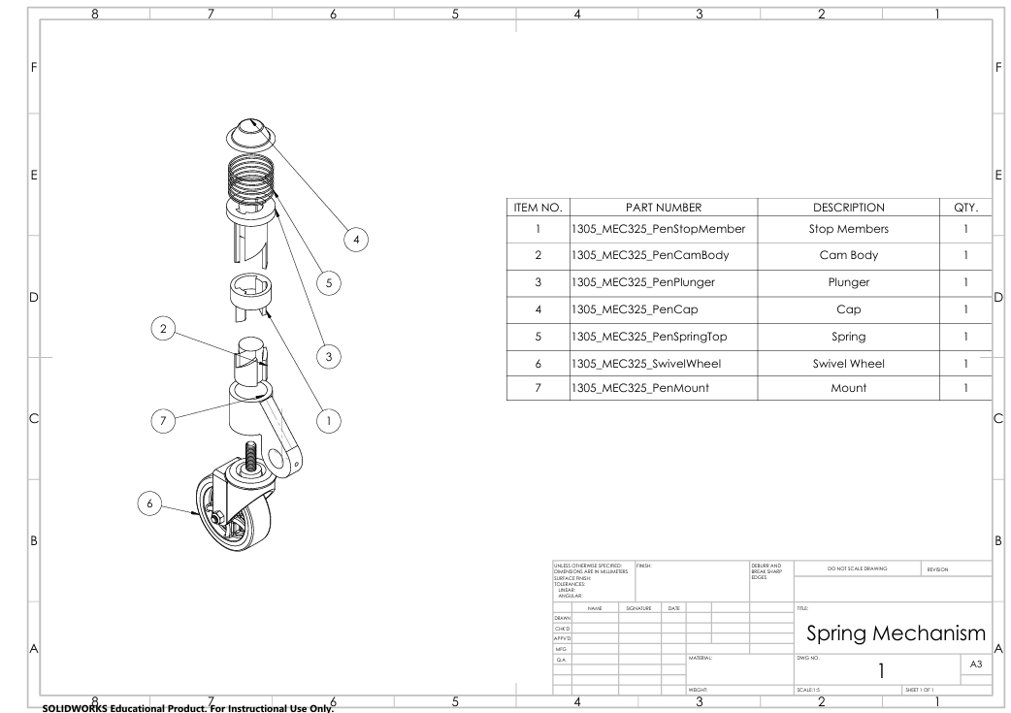

The subassembly illustrated above is a fifth wheel that has 360 degrees of freedom, also known as a “swivel wheel”. Its intended purpose is to drop down when needed, raising the two back wheels such that the entire device is supported by 3 wheels which are all swivel wheels (2 front, 1 back). This allows for increased maneuverability in tight spaces such as public transport. The ability to toggle the fifth wheel when desired is crucial due to the fact that an all- swivel wheel device offers much less stability, and is only useful in certain situations. The toggle system design takes direct inspiration from a push-pen, allowing the user to step once to lower the wheel and step a second time to raise it.

*\*See references [6], [7] for utilized CAD file citations.*

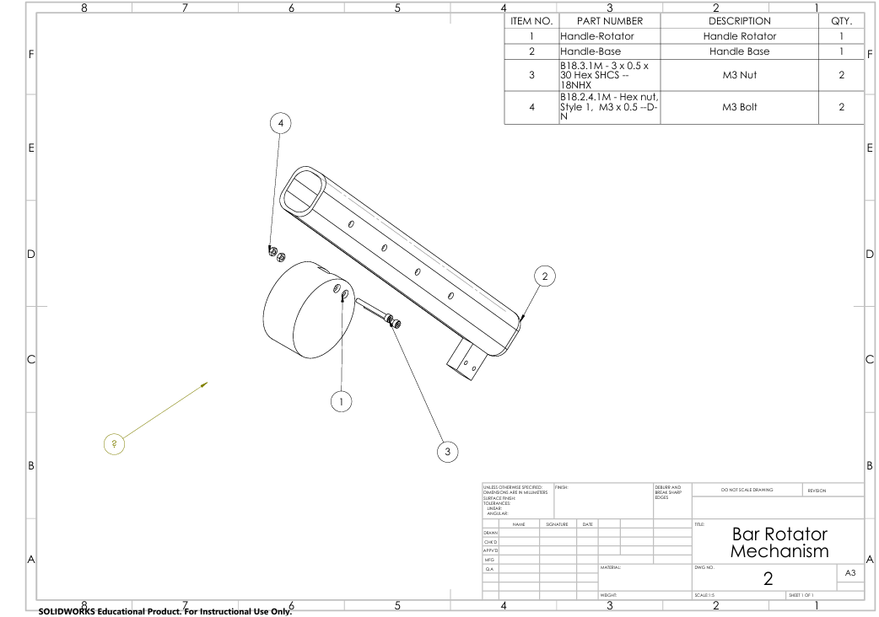

The subassembly illustrated above allows for rotational movement of the handlebars, which is used in the folding of the device. The mount for the handlebars also features 4 holes, which are used to house spring clips (See [SKB 9.1](https://docs.google.com/document/d/1rz1rAIiTk1ZrDwnuDpjA3R7Bg03I_6vg5hg59ztqgEg/edit?tab=t.0#bookmark=id.6srt4bm3in73)). This allows the handlebar height to be adjustable, making the height from the ground to the handlebar range from 104 cm to 114 cm, with options in between. This design choice allows for a wider range of users, and more specifically allows use by all persona’s, ranging from the shortest persona, Caitlynn to the tallest, John.

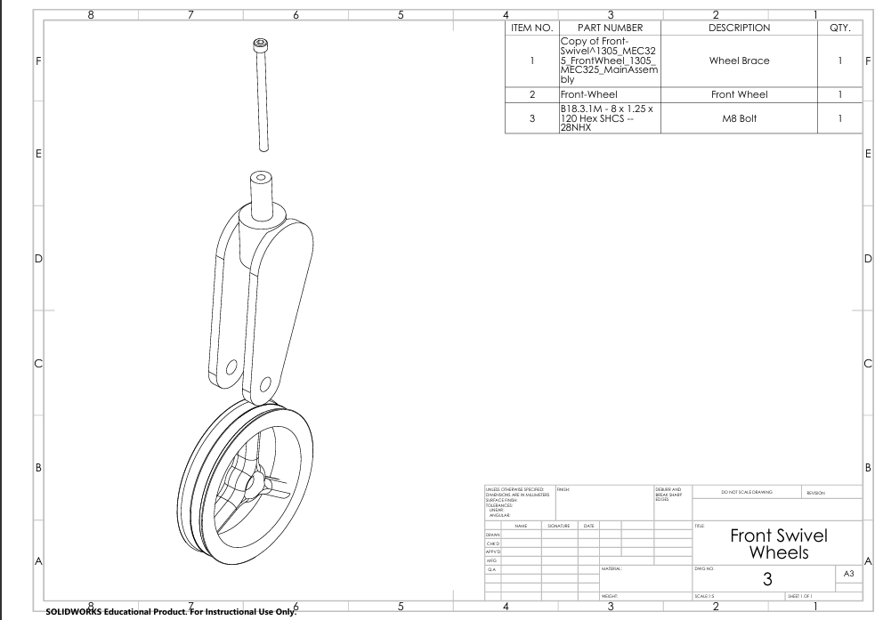

The subassembly illustrated above is the design of the two front swivel wheels of the device, which feature a caster angle of 15॰, increasing the stability and allowing for easier course correction when traveling straight (see [SKB 5.5](https://docs.google.com/document/d/1rz1rAIiTk1ZrDwnuDpjA3R7Bg03I_6vg5hg59ztqgEg/edit?tab=t.0#bookmark=id.ursza3erk4wc)).

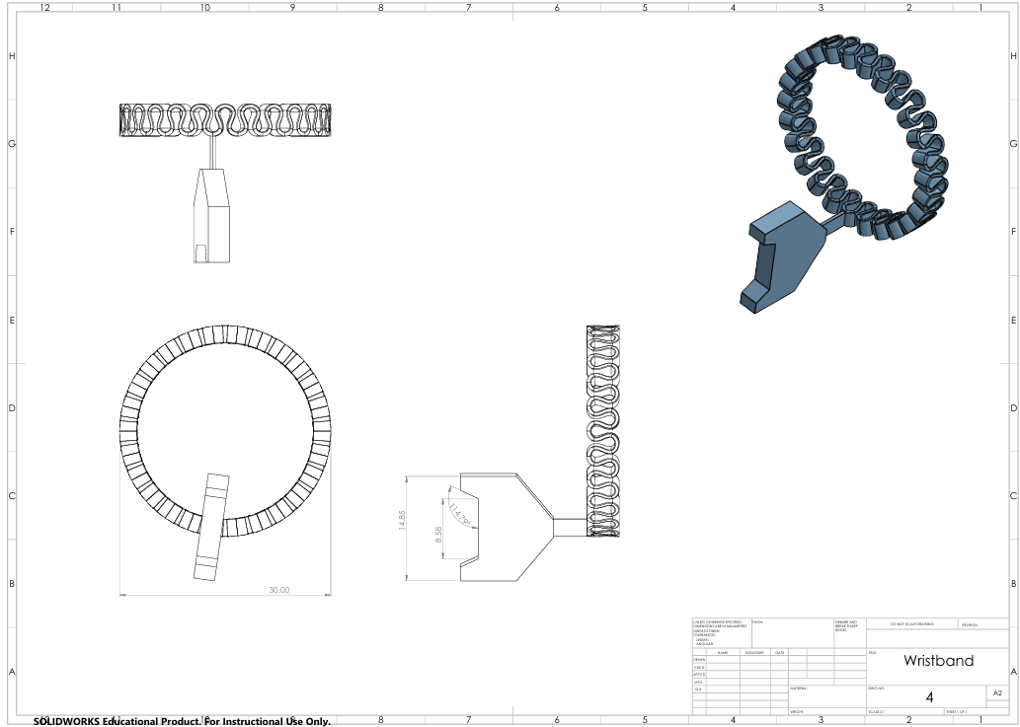

The design above illustrates the design for a wristband worn by the users at all times during use that connects to the top of the handlebar. This safety system is in place such that if an accident occurs and the user loses control of the device such that the wristband detaches from the handle, the breaks are activated so that the device comes to a stop.

*\*See references [8] for utilized CAD file citations.*

# 

# design issues

**Step 1a**: Users with limited strength (e.g., Jameson, Rachel) may struggle with unfolding the device; an automated or assisted unfolding mechanism would enhance usability.  
**Step 1b**: Users like Thanh with dexterity challenges may find the locking process difficult; a hands-free locking system or large, easy-to-grip levers would help.  
**Step 1c**: Tall users like John or those with limited strength may find manual handlebar adjustments challenging; integrate a one-touch height adjustment mechanism.  
**Step 1d**: Manual seat adjustments may require excessive force; a motorized or lever-based system would improve accessibility for users like Caitlynn.

**Step 2a**: Users with reduced strength (e.g., Jameson) may still find pushing difficult on inclines; include power-assist functionality for such situations.  
**Step 2b**: Uneven terrain may destabilize the intervention when the fifth wheel is deployed; add a locking mechanism for stability on rough surfaces.  
**Step 2c**: Users with limited dexterity (e.g., Thanh) may find engaging the brakes cumbersome; a hand-activated brake system would offer an alternative.  
**Step 2d**: Navigating tight spaces may require more coordination than some users, such as Margaret, can manage; include a self-stabilizing system.

**Step 3a**: Users like Margaret or Thanh may find unbuckling the harness cumbersome; quick-release mechanisms should be integrated.  
**Step 3b**: Retracting and locking the fifth wheel may require precise coordination; automate or simplify this step for users with physical limitations.  
**Step 3c**: Folding the intervention may overwhelm users with limited memory (e.g., Margaret); a guided one-step folding system with visual prompts would help.  
**Step 3d**: Users with mobility issues (e.g., Caitlynn) may struggle with storing the folded intervention; integrate carry handles or wheels for easier transport.

## CEC Analysis Charts

| HF DEMAND | US STEP WITH HIGHEST DEMAND (#, description | % Excluded | Comment |
| --- | --- | --- | --- |
| Vision | 1I - Ensure the wrist strap is secured around the wrist | 0.7 | The user must visually confirm the wrist strap is secured properly for correct usage |
| Hearing | 1B - Lock in the fifth wheel into the neutral position | 0.9 | The user must listen for audible feedback in order to confirm the fifth wheel is locked correctly into place |
| Concentration memory | 2D - In case of emergency pulling the wrist strap safety feature engages an immediate stop of the intervention | 2.6 | The user must recall the usage of the strap in case of an emergency and remember that the strap is secured around the wrist, ready to be pulled when needed. |
| Strength & dexterity (dominant) | 3E - Engage the folding mechanism to compact the intervention into a small easily storable size, ensuring all locks are fastened and the mechanism is folded completely | 8.7 | The user must manually engage the folding mechanism in order to properly store the intervention and it must be done ensuring the locks are fastened and the intervention is correctly folded. |
| Strength & dexterity (non-dominant) | 1D - Adjust the seating type by pressing the middle seat lock in order to change the seating type to fit co-users comfort | 8.9 | The user must manually adjust the seating type by unlocking the middle lock and moving the seat to the desired position. |
| Walking and Mobility | 2A - Push the intervention forward with minimal effort through the lightweight | 7.5 | Pushing the intervention forward requires both strength & mobility in order to move the intervention. It requires the ability to walk over various types of terrains in order to manage the intervention. |

# 

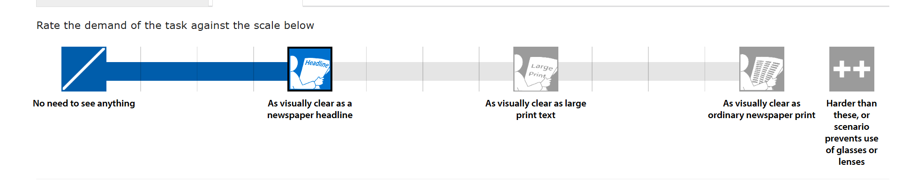

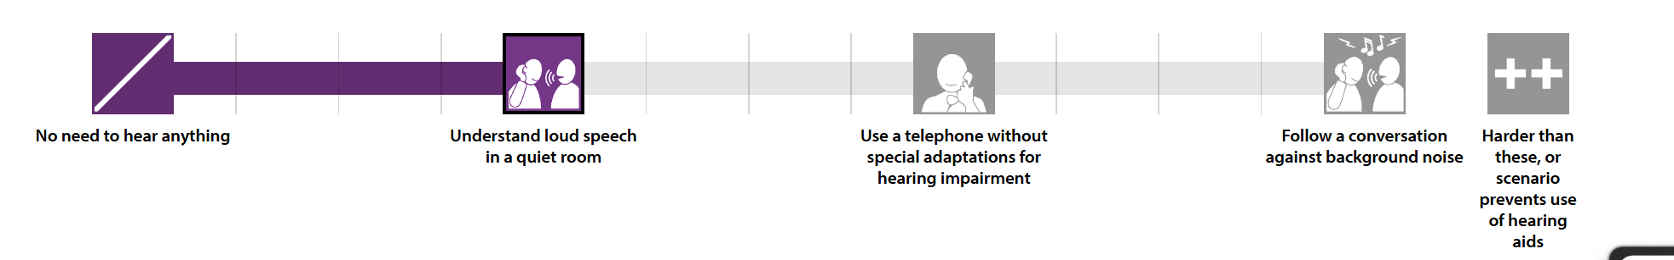

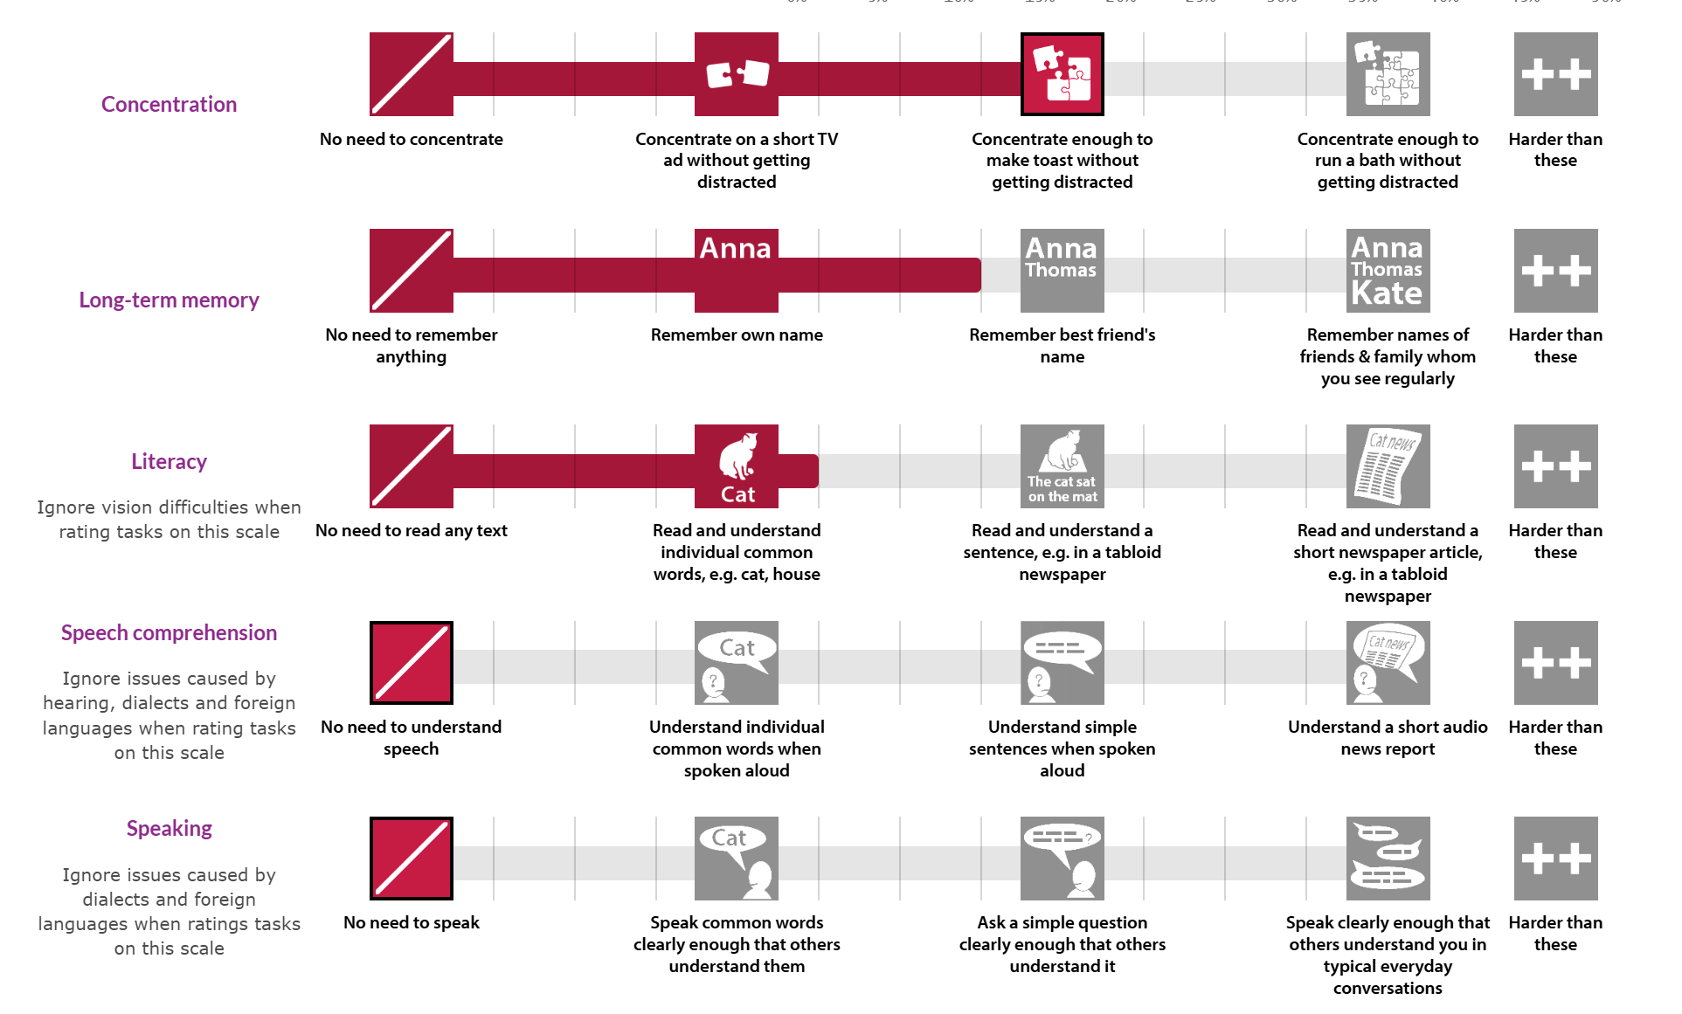

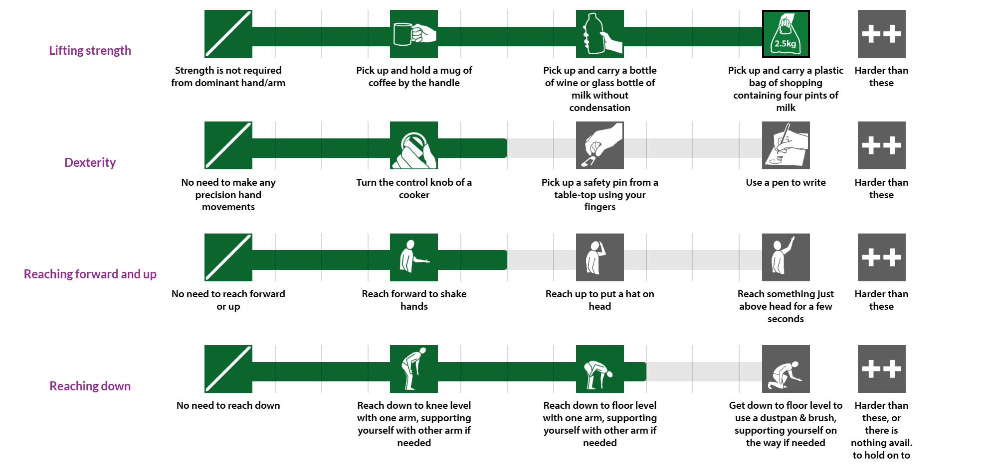

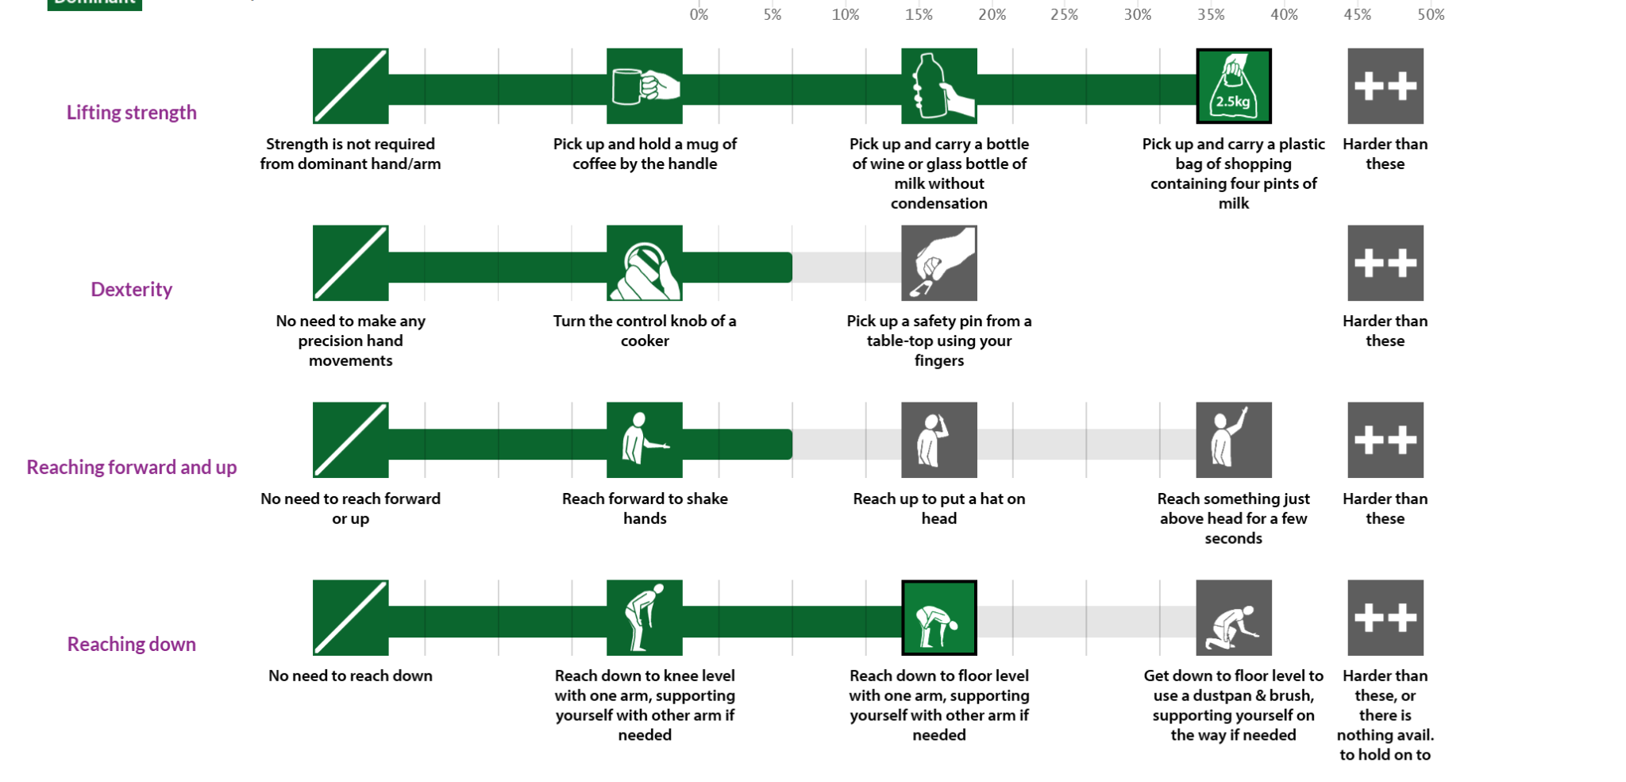

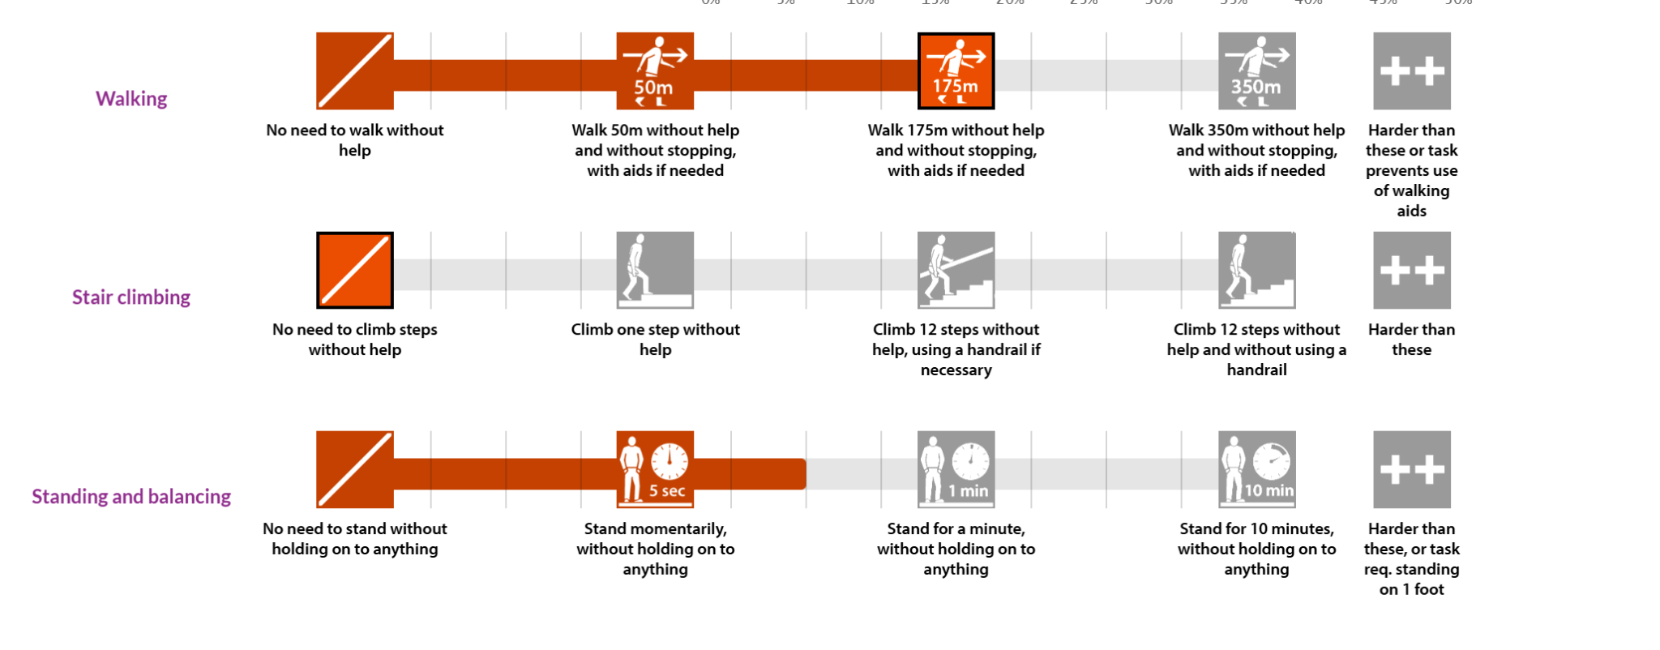

# CAD drawings

### main assembly drawing

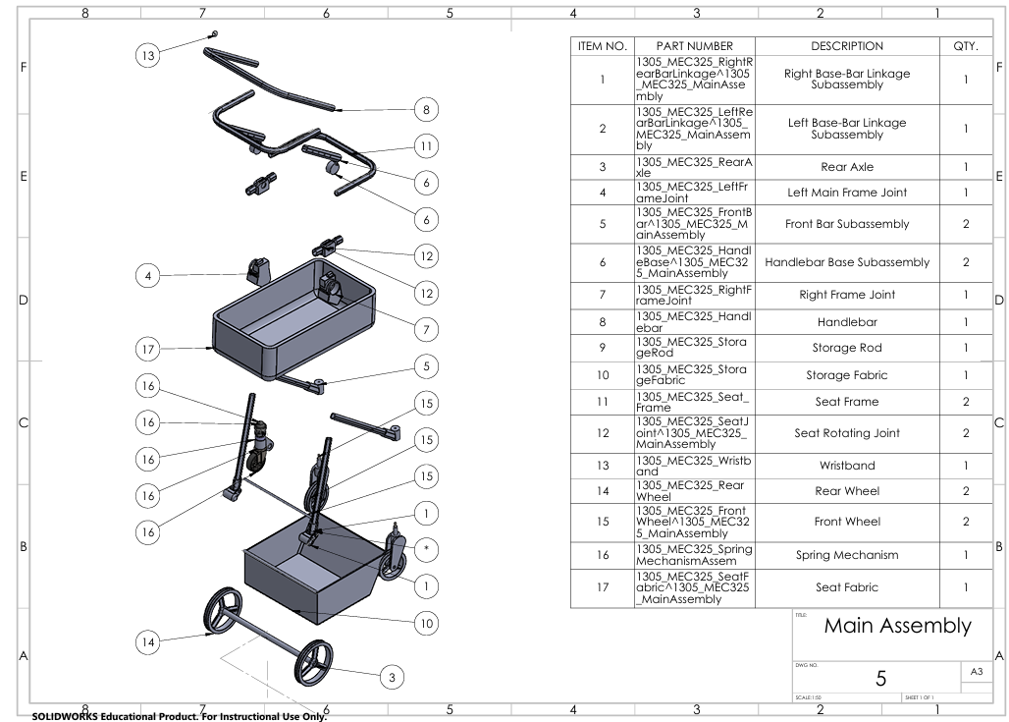

### 

### 

### 

### 

### 

### 

### 

### drawing no. 1



### 

### 

### 

### drawing no. 2



### 

### 

### 

### drawing no. 3



### 

### 

### 

### 

### 

### 

### drawing no. 4



### drawing no. 6

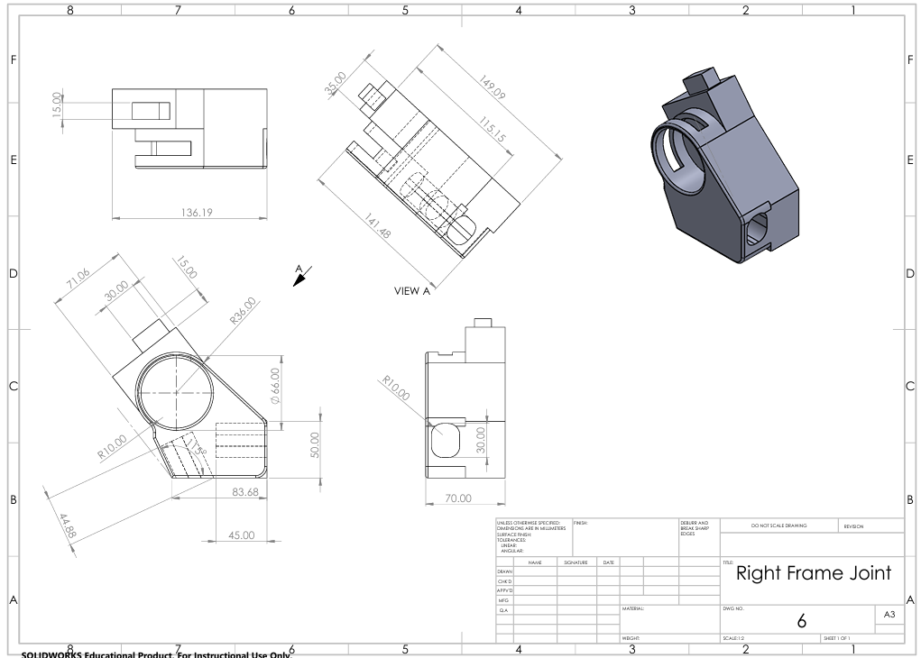

### drawing no. 7

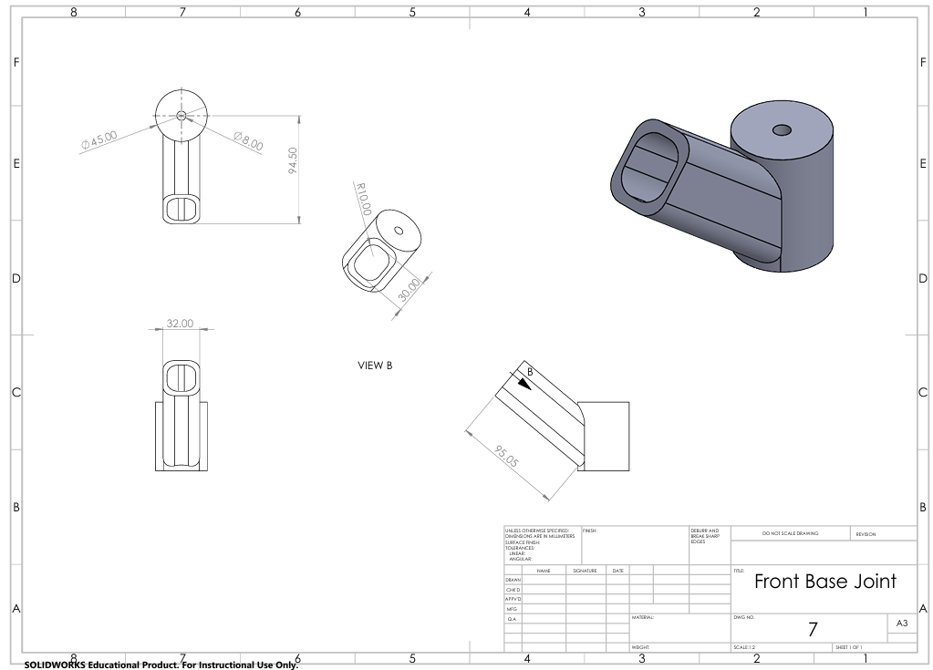

### 

### 

### 

### drawing no. 8

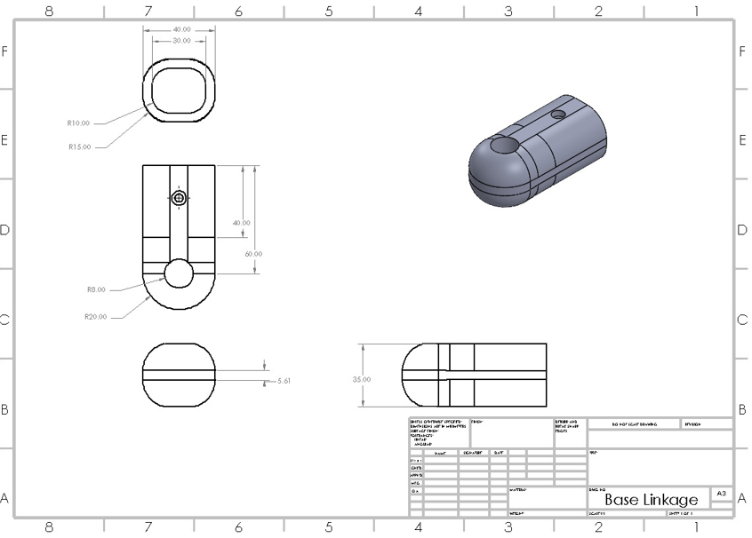

### drawing no. 9

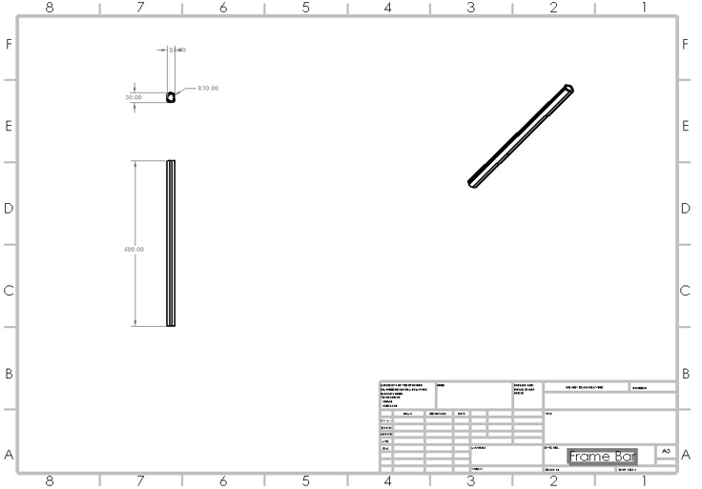

### 

### 

### 

### 

### 

### 

### 

### drawing no. 10

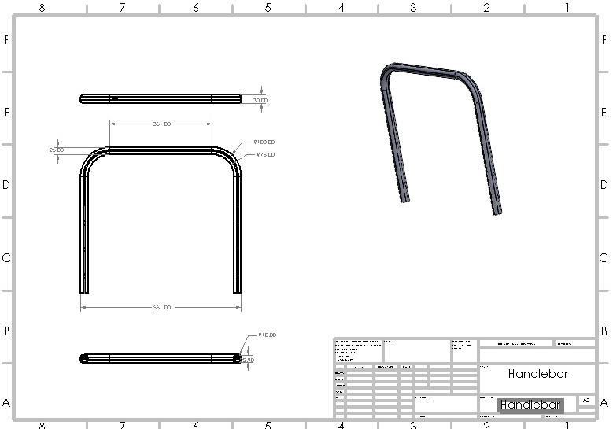

### 

### 

### 

### 

### 

### 

### 

### drawing no. 11

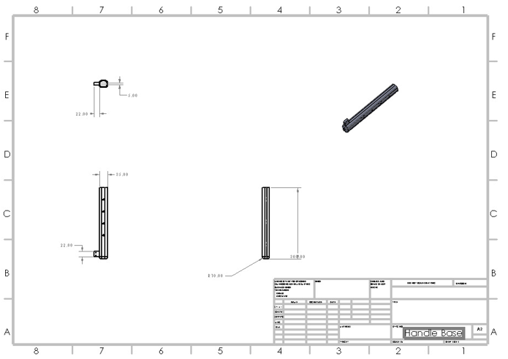

# 

# references

[1] [Situational Knowledge Base](https://docs.google.com/document/d/1rz1rAIiTk1ZrDwnuDpjA3R7Bg03I_6vg5hg59ztqgEg/edit?tab=t.0)

[2] [Product Requirements Specification](https://docs.google.com/document/d/1koir-KUa0VVEAbeYr69YBJmGd06drHKx8WeN1O9Ox0A/edit?tab=t.0)

[3] [Product Design Specification](https://docs.google.com/document/d/19KGi0PIx9DB-yrT7nRob-Qy8iMO80u0HPKYj3moV8S4/edit?usp=sharing)

[4] Inclusive Design Toolkit, 2024, "Capability Loss Calculator," Inclusive Design Toolkit, University of Cambridge, Cambridge, UK, accessed Nov. 11, 2024,<https://calc.inclusivedesigntoolkit.com/>

[5] [Design Brief](https://docs.google.com/document/d/1m8Y97Fyu418LrBMM7_kaH58dcY6xXEpoC8NbKqFQzBs/edit?tab=t.0#heading=h.plg5fdf1bsja)

[6] P. Arthurs, “Ballpoint pen mechanism (double-click)” The GrabCAD Community Library, [https://grabcad.com/library/ballpoint-pen-mechanism-double-click](https://grabcad.com/library/ballpoint-pen-mechanism-double-click-1/details?folder_id=14058454) (accessed Dec. 3, 2024).

[7] the_Natrix, “4" Caster Swivel w/ Vintage Wheel Poly Tread, 1/2"-13 Stem,” The GrabCAD Community Library, <https://grabcad.com/library/4-caster-swivel-w-vintage-wheel-poly-tread-1-2-13-stem-1> (accessed Dec. 3, 2024).

[8] J. S. S. Silva, “Diseño de Manilla - Wristband design,” The GrabCAD Community Library, <https://grabcad.com/library/diseno-de-manilla-wristband-design-1> (accessed Dec. 3, 2024).

1. Only the last 5 digits of the student number are required.